UNIVERSITY OF SCIENCE AND TECHNOLOGY OF HANOI



REPORT

WEBSITE APPLICATION DEVELOPMENT



TOPIC

BUILD A WEB APPLICATION TO MANAGE MRI IMAGE DATA OF A CLINIC

Instructor: Dr. NGHIEM Thi Phuong

Contents

I. **OVERVIEW** 2

**1.** **About** 2

**2.** **Class** 2

**3.** **Topic** 2

**4.** **Roles** 2

**5.** **Why Need MRI Image Manager** 2

**6.** **What MRI Image Manager Do** 2

II. **THEORETICAL BASIS** 2

**1.** **Research Topic** 2

**2.** **Summary** 3

**3.** **Analysis and Evaluation** 3

**4.** **Conclusion** 3

III. **PROJECT CONTENT** 4

**1.** **UI Design** 4

**2.** **Function** 6

**3.** **Database** 8

IV. **RESULT** 9

# **OVERVIEW**

## **About**

* Group name: Group 14
* Group member:
  + Pham Gia Phuc – BI10-138
  + Tran Dac Minh – BI10-113
  + Do Hoang Quan – BI10-147
  + Dang Gia Linh – BI10-101

## **Class**

* ICT

## **Topic**

* Build a web application to manage MRI image data of a clinic
* Language used: HTML, Javascript, PHP, SQL

## **Roles**

* UI Designer and coding: Do Hoang Quan
* Function developer: Pham Gia Phuc
* Dataset & PHP developer: Tran Dac Minh
* Document researcher and summary: Dang Gia Linh

## **Why Need MRI Image Manager**

* Number of employees: growing up
* Need better way to storage and manage resources
* Much more efficient than paper bases.

## **What MRI Image Manager Do**

* MRI Image Manager
  + Provide information of the clinic
  + Create and store patient MRI data
  + Read MRI data

# **THEORETICAL BASIS**

## **Research Topic**

* Build a web application to manage MRI image data of a clinic
* Language: HTML, CSS, Javascript, PHP, SQL

## **Summary**

* **HTML** is the standard markup language for Web pages.
* **CSS** is the style sheet language used for describing the presentation of a document written in a markup language such as HTML
* **JavaScript** is the world's most popular programming language. JavaScript is the programming language of the Web.
* **PHP** is a server scripting language, and a powerful tool for making dynamic and interactive Web pages. PHP is a widely-used, free, and efficient alternative to competitors such as Microsoft's ASP.
* **SQL** is a standard language for storing, manipulating and retrieving data in databases.

## **Analysis and Evaluation**

* **Hypertext markup language (HTML)** is a Hypertext markup language, the standard markup language for documents designed to displayed and viewed on the online during a browser also helps to create the structure of the web page. because it is a markup language, it consists of many tags.
* **Cascading Style Sheets (CSS)** is defined as a method sheet language that provides web designers control over how an internet site communicates with web browsers including the formatting and display of their HTML documents.
* **JavaScript is a programming language.** Many of these are related to the way, JavaScript is often executed directly in a client’s browser commonly utilized in web development.
* The name **PHP** stands for **Hypertext Preprocessor** and denotes a server-side scripting language, which suggests that applications written thereon run on web servers and don’t depend upon the online browser.
* **Structural Query Language (SQL)** is used for accessing, manipulating, and communicating with the database.

1. **Conclusion**

* HTML is standard markup language, easy to study and use, minimal flaws.
* CSS is easy to study but pretty hard to use.
* Javascript is a stable programming language.
* PHP is a powerful language but hard in usage.
* SQL is a great language for working with kinds of data.

# **PROJECT CONTENT**

## **UI Design**

**HOME PAGE**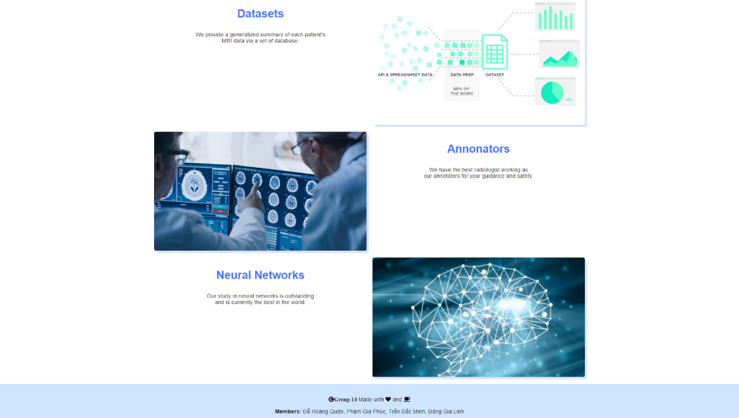

**SERVICES PAGE** 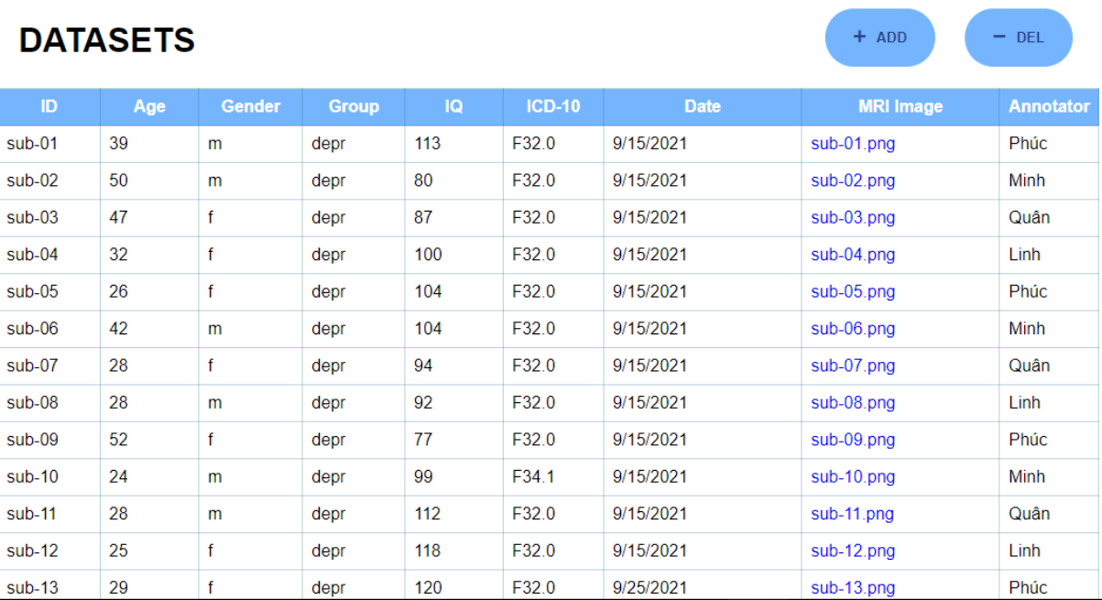

*When ADD button is clicked* 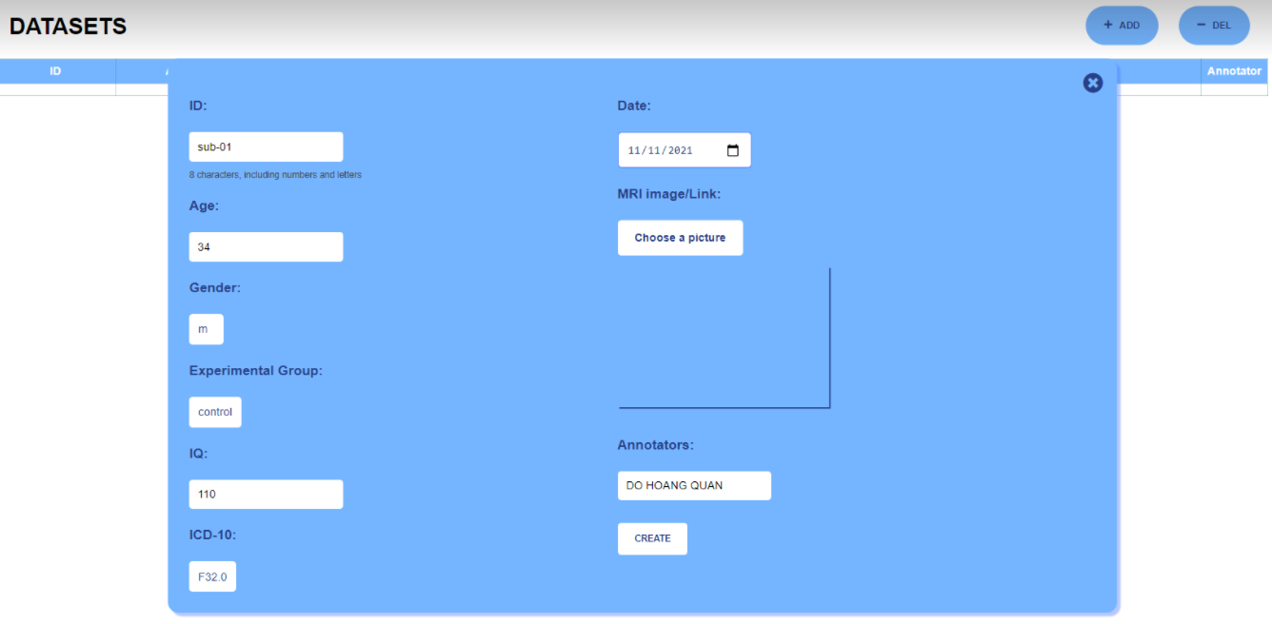

*When DEL button is clicked* 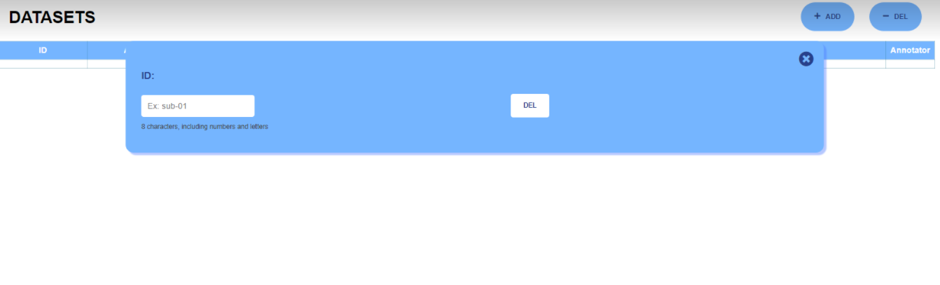

**STAFF PAGE**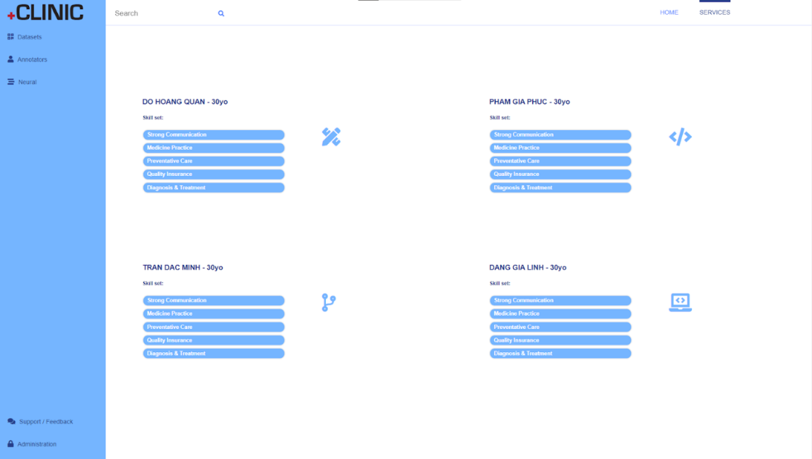

## **Function**

1. **Introduce the most prominent information of the Clinic**

Generalize summary of patient’s MRI data via a set of database.

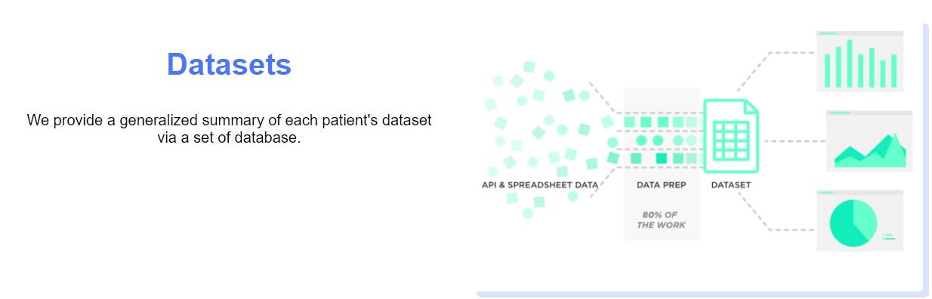

Introduce the annotators

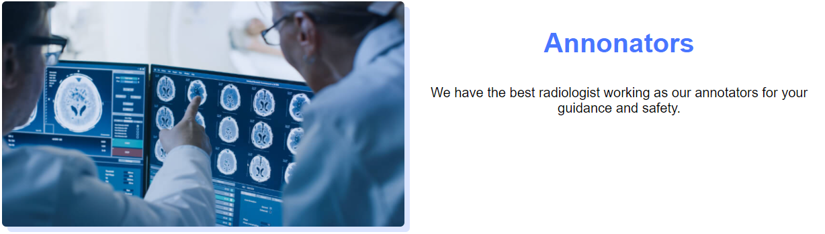

Introduce the outstanding neural networks, which is the best in the world.

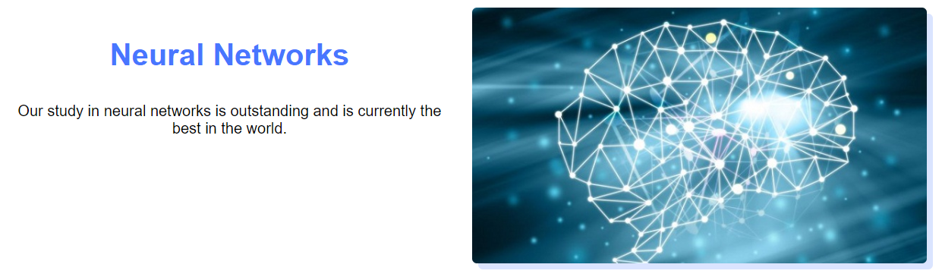

Provide contact information of the clinic



1. **Read and display dataset**

The website reads the database, which contains lines of dataset. Once access to the “Dataset” page, the Website display all Database, which contains 6 categories, which provide the basic information of patient:

* + ID
  + Age
  + Gender
  + Group
  + IQ
  + ICD-10
  + Date
  + MRI Image
  + Annotator

1. **Create MRI dataset**

It is necessary to add new data of the patient in the working time, therefore, MRI Image Manager provides the function of adding new data to the database of Clinic.

Input value of categories and new information of patients is created.

1. **Store MRI dataset:**

For every newly added dataset, it is necessary to keep it safe for the working process of the Clinic, thus, new-create-data will be added and saved to the database, then being displayed in the table.

## **Database**

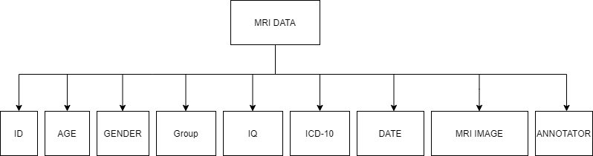

The dataset consists of 72 records from 72 voluntary participants.

The experiment divided participants into 2 groups: depressed and healthy control.

Data descriptions

* 1. ID – participants identifier
  2. Age – age of participants
  3. Gender – male/female (m/f)
  4. Group – depressed/healthy control (depr/control)
  5. IQ – IQ scores on Raven's Progressive Matrices (0 – 200)
  6. ICD-10 – International Statistical Classification of Diseases and Related Health Problems 10th Revision

"F32.0": "Mild depressive episode"

"F32.1": "Moderate depressive episode"

"F34.1": "Dysthymia"

"F34.9": "Persistent mood disorder, unspecified"

* 1. Date – format of ***dd/mm/yyyy***
  2. MRI Image – link to MRI image
  3. Annotator

Dr. Phuc

Dr. Minh

Dr. Quan

Dr. Linh

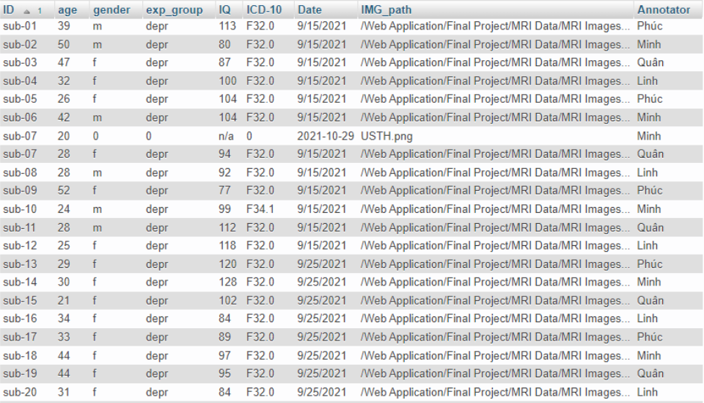

# **RESULT**

In general, MRI Image Manager is a great web based application.

The website has a simple user interface, which increases the friendliness in usage.

Otherwise, MRI Image Manager uses a database which is pretty detailed, organized in a kind of table, it helps users easier to look up and manage the information of patients.

Be able to search with all kinds of categories.

However, the web has a bit of a lack of responses. Furthermore, when adding information, users have to type every single input line to have full information. If mistakenly added with the lack of information, users need to redo the process to have the full one.

At the moment, we are working with our best to update and get a better application for the greatest experiences of users.